Booking And Payment Management

**Booking Activity Diagram**

**Payment Activity Diagram**

Sequence Diagram

Booking UI

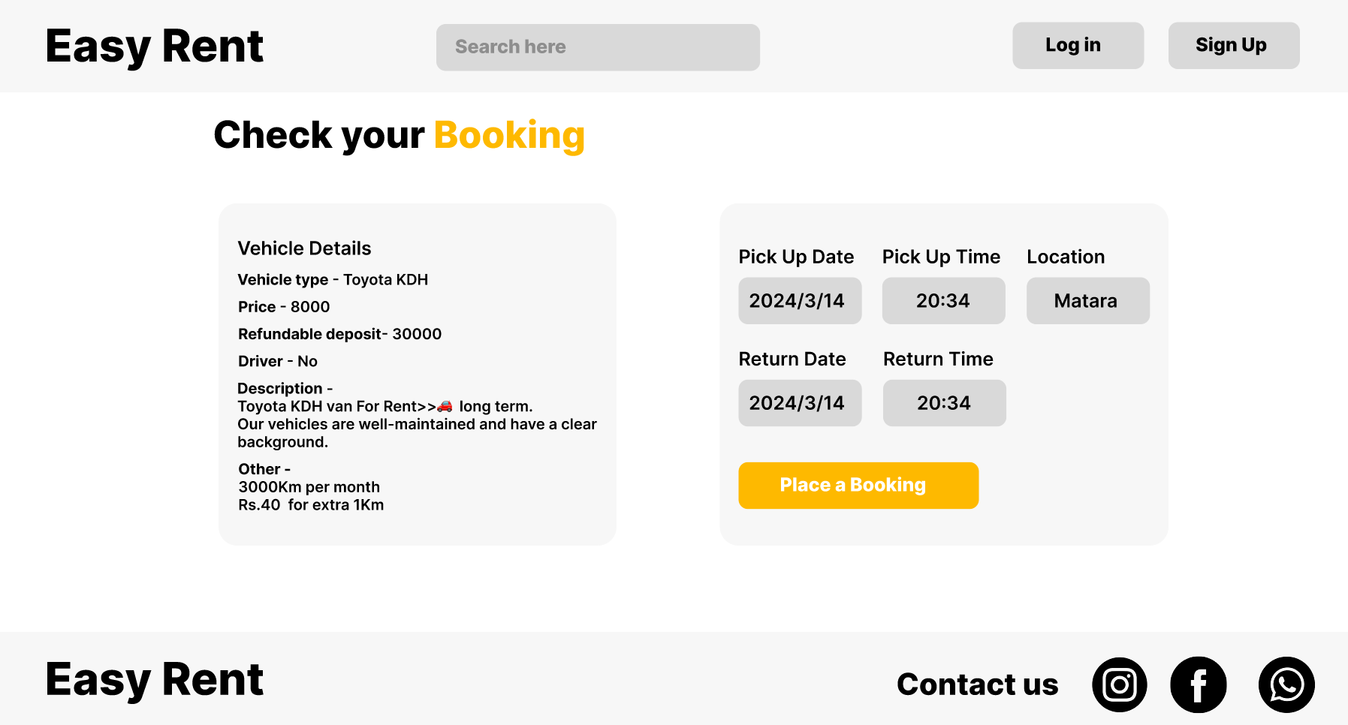

Payment UI

